TABLE OF CONTENTS

S.NO | TITLE | PAGE NO
1. | Abstract | 5
2. | Introduction | 6
3. | Software Specifications | 7
4. | Tools Used | 8
5. | Modules Used | 13
6. | Coding | 14
7. | Database Design | 32
8. | Output | 34
9. | Conclusion | 39
10. | References | 40

4
ABSTRACT

The Library Management System is for monitoring and controlling the transactions in a library. The project "Library Management System" is developed in ASP.NET and uses MySQL as backend which mainly focuses on basic operations in a library like adding new books, and updating new information, searching books, maintaining stock, and facility to borrow and return books. It contains work like the number of available books in the library, the number of books are issued or returning. "Library Management System" is a Web application written in Visual Studio 2019, designed to help users maintain and organize library. This software is easy to use for both beginners and advanced users. This system will reduce all the manual work and the whole process can be managed just through single clicks and edits.

5
INTRODUCTION

Library Management software focuses on monitoring and controlling the transactions in a library. The project “Library Management System” is developed in ASP.NET, which mainly focuses on basic operations in a library like adding new books, and updating new information, searching books and members and return books. Library management system that offers many flexible and convenient features, allowing librarians and library users to maximize time and efficiency. Library System gives the all detailed information about students, staff and books. It will track on the how many books available in library and books issued to the students.
ASP.NET 2.0 introduces many exciting and important features for web developers. One of the most powerful is the portal framework. We can use the portal framework’s new Web Parts technology to build dynamic web portals. The database connectivity is planned using the “SQL Connection” methodology. The standards of security and data protective mechanism have been given a big choice for proper usage. The application takes care of different modules and their associated reports, which are produced as per the applicable strategies and standards that are put forwarded by the administrative staff.

6
SYSTEM SPECIFICATIONS
- HARDWARE REQUIREMENTS

System

: Intel i3core

Hard Disk

: 8GB

Monitor

: 14’Color Monitor

Mouse

: Optical Mouse

- SOFTWARE REQUIREMENTS

Operating system | : Windows7/8/10
Coding Language | : | ASP.Net with C#
Database | : | MySQL
Front End Tool | : Microsoft Visual studio 2019
Back End Tool | : XAMPP

7

TOOLS USED
- ASP.NET

ASP.NET is an open source, server-side web application framework created by Microsoft that runs on Windows and was started in the early 2000s. ASP.NET allows developers to create web applications, web services, and dynamic content-driven websites. ASP.NET supports industry standard authentication protocols. Built-in features help protect your apps against cross-site scripting (XSS) and cross-site request forgery (CSRF).ASP.NET provides a built-in user database with support for multi-factor authentication and external authentication with Google, Twitter, and more.

Why to use it?

There are plenty of good reasons to use ASP.NET when developing a website or an application. High speed, low cost, and vast language support are among the most significant benefits. ASP.NET is built into the familiar Windows server environment, requiring less setup and configuration than other web development platforms that must be installed and configured separately. The popularity of ASP.NET makes online resources and skilled developers easy to find. Websites and applications built with ASP.NET can be faster and more efficient than a website build with PHP, for example. ASP.NET applications are compiled, which means the code is translated into object code, which is then executed. This compilation process takes a small amount of time, but happens only once. After compilation, the code can be executed over and over by the .Net platform very quickly.

8

ASP.NET WEB FORMS

ASP.NET web forms extend the event-driven model of interaction to the web applications. The browser submits a web form to the web server and the server returns a full markup page or HTML page in response.

All client side user activities are forwarded to the server for stateful processing. The server processes the output of the client actions and triggers the reactions.

Now, HTTP is a stateless protocol. ASP.NET framework helps in storing the information regarding the state of the application, which consists of:

- Page state

- Session state

The page state is the state of the client, i.e., the content of various input fields in the web form. The session state is the collective information obtained from various pages the user visited and worked with, i.e., the overall session state. To clear the concept, let us take an example of a shopping cart.

User adds items to a shopping cart. Items are selected from a page, say the items page, and the total collected items and price are shown on a different page, say the cart page. Only HTTP cannot keep track of all the information coming from various pages. ASP.NET session state and server side infrastructure keeps track of the information collected globally over a session.

The ASP.NET runtime carries the page state to and from the server across page requests while generating ASP.NET runtime codes, and incorporates the state of the server side components in hidden fields.

This way, the server becomes aware of the overall application state and operates in a two-tiered connected way.

9
C#

C# is a modern, general-purpose, object-oriented programming language developed by Microsoft and approved by European Computer Manufacturers Association (ECMA) and International Standards Organization (ISO).C# was developed by Anders Hejlsberg and his team during the development of .Net Framework.

C# is designed for Common Language Infrastructure (CLI), which consists of the executable code and runtime environment that allows use of various high-level languages on different computer platforms and architectures.

Microsoft provides the following development tools for C# programming −

- Visual Studio 2010 (VS)

- Visual C# 2010 Express (VCE)

- Visual Web Developer

The last two are freely available from Microsoft official website. Using these tools, you can write all kinds of C# programs from simple command-line applications to more complex applications. You can also write C# source code files using a basic text editor, like Notepad, and compile the code into assemblies using the command-line compiler, which is again a part of the .NET Framework.

Visual C# Express and Visual Web Developer Express edition are trimmed down versions of Visual Studio and has the same appearance. They retain most features of Visual Studio.

10
MySQL

MySQL is a relational database management system developed by Oracle. As a database server, it is a software product with the primary function of storing and retrieving data as requested by other software applications—which may run either on the same computer or on another computer across a network (including the Internet). Oracle markets at least a dozen different editions of MySQL, aimed at different audiences and for workloads ranging from small single-machine applications to large Internet-facing applications with many concurrent users.

Similar to other RDBMS software, MySQL is built on top of MySQL, a standard programming language for interacting with the relational databases. MySQL is tied to Transact-SQL, or T-MySQL, the Oracle’s implementation of MySQL that adds a set of proprietary programming constructs.

Database Engine

The core component of the MySQL is the Database Engine. The Database Engine consists of a relational engine that processes queries and a storage engine that manages database files, pages, pages, index, etc. The database objects such as stored procedures, views, and triggers are also created and executed by the Database Engine.

- Relational Engine

The Relational Engine contains the components that determine the best way to execute a query. The relational engine is also known as the query processor.

The relational engine requests data from the storage engine based on the input query and processed the results.

11

Some tasks of the relational engine include querying processing, memory management, thread and task management, buffer management, and distributed query processing.

- Storage Engine

The storage engine is in charge of storage and retrieval of data from the storage systems such as disks and SAN.

12
MODULES USED

- Login

- Book Entry

- Book Search

- Book Issue
- Book Return
- Stock Maintenance

13
CODING

Login

Login.aspx.cs

using System;
using System.Collections.Generic;
using System.Linq;
using System.Web;
using System.Web.UI;
using System.Web.UI.WebControls;

namespace LibraryManagement
{
public partial class login : System.Web.UI.Page
{
protected void Page_Load(object sender, EventArgs e)
{

}

protected void Button1_Click(object sender, EventArgs e)
{
if (id.Text == "lms" && pass.Text == "lms")
{

Response.Redirect("home.aspx");
}
else
{
Response.Write("<script>alert('Incorrect Login Again');</script>");

}
}
}

bookEntry.aspx.cs

using System;
using System.Collections.Generic;
using System.Linq;
using System.Web;
using System.Web.UI;
using System.Web.UI.WebControls;
using System.Data;
using MySql.Data.MySqlClient;

namespace LibraryManagement
{
public partial class bookEntry : System.Web.UI.Page
{
String mycon = "Server=localhost; Database=test; Uid=root; Password=;";

protected void Page_Load(object sender, EventArgs e)
{

}

protected void submit_Click(object sender, EventArgs e)
{
MySqlConnection con = new MySqlConnection(mycon);
try
{
if (con.State == ConnectionState.Closed)
{
con.Open();
}

//insert into book return
MySqlCommand cmd = new MySqlCommand("insert into bookentry(bookLNo,bookName,authorName,category,subject,price,status) values(@a1,@a2,@a3,@a4,@a5,@a6,@7)", con);
cmd.Parameters.AddWithValue("@a1", bookLNo.Text.Trim());
cmd.Parameters.AddWithValue("@a2", bookName.Text.Trim());
cmd.Parameters.AddWithValue("@a3", authorName.Text.Trim());
cmd.Parameters.AddWithValue("@a4", category.Text.Trim());
cmd.Parameters.AddWithValue("@a5", subject.Text.Trim());
cmd.Parameters.AddWithValue("@a6", price.Text.Trim());
cmd.Parameters.AddWithValue("@a7", "active");
cmd.ExecuteNonQuery();

Response.Write("<script>alert('Book Added Successfully')</script>");

}
catch (Exception ex)
{
Response.Write("<script>alert('" + ex.Message + "')</script>");
}
finally
{
con.Close();
//clear all fields
bookName.Text = "";
bookLNo.Text = "";
authorName.Text = "";
category.Text = "";
price.Text = "";
subject.Text = "";

}

}
}
}

bookSearch.aspx.cs

using System;
using System.Collections.Generic;
using System.Linq;
using System.Web;
using System.Web.UI;
using System.Web.UI.WebControls;
using System.Data;
using MySql.Data.MySqlClient;

namespace LibraryManagement
{
public partial class bookSearch : System.Web.UI.Page
{
String mycon = "Server=localhost; Database=test; Uid=root; Password=;";
protected void Page_Load(object sender, EventArgs e)
{

}

protected void submit_Click(object sender, EventArgs e)
{
MySqlConnection con = new MySqlConnection(mycon);
try
{
if (con.State == ConnectionState.Closed)
{
con.Open();
}

//grid view for all the books user issued and active
MySqlCommand cmd = new MySqlCommand("select bookName as 'Book Name', authorName as 'Author Name', category as 'Category', subject as 'Subject', price as 'Price' from bookentry WHERE bookLNo='" + bookLNo.Text.Trim() + "' ", con);
MySqlDataAdapter da = new MySqlDataAdapter(cmd);
DataTable dt = new DataTable();
da.Fill(dt);

if (dt.Rows.Count >= 1)
{
GridView1.DataSource = dt;
GridView1.DataBind();
}
else
{
Response.Write("<script>alert('Book not found!')</script>");
GridView1.DataSource = null;
GridView1.DataBind();
}

}
catch (Exception ex)
{
Response.Write("<script>alert('" + ex.Message + "')</script>");
}
finally
{
con.Close();

}
}

protected void Button1_Click(object sender, EventArgs e)
{
MySqlConnection con = new MySqlConnection(mycon);
try
{
if (con.State == ConnectionState.Closed)
{
con.Open();
}

//grid view for all the books user issued and active
MySqlCommand cmd = new MySqlCommand("select bookLNo as 'Book L No', bookName as 'Book Name', authorName as 'Author Name', category as 'Category', subject as 'Subject', price as 'Price' from bookentry ", con);
MySqlDataAdapter da = new MySqlDataAdapter(cmd);
DataTable dt = new DataTable();
da.Fill(dt);

if (dt.Rows.Count >= 1)
{
GridView1.DataSource = dt;
GridView1.DataBind();
}
else
{
Response.Write("<script>alert('Book not found!')</script>");
GridView1.DataSource = null;
GridView1.DataBind();
}

}
catch (Exception ex)
{
Response.Write("<script>alert('" + ex.Message + "')</script>");
}
finally
{
con.Close();

}
}
}
}

bookIssue.aspx.cs

using System;
using System.Collections.Generic;
using System.Linq;
using System.Web;
using System.Web.UI;
using System.Web.UI.WebControls;
using System.Data;
using MySql.Data.MySqlClient;
using System.Web.UI.WebControls.Expressions;

namespace LibraryManagement
{
public partial class WebForm1 : System.Web.UI.Page
{
//string mycon = "server =localhost; Uid=root; password = ; persistsecurityinfo = True; database =test; SslMode = none;";
string mycon = "Server=localhost;Database=test;Uid=root;Password= ;";

protected void Page_Load(object sender, EventArgs e)
{
//issue date (today)
issueDate.Text = System.DateTime.Now.ToString("dd-MM-yyyy");
// DateTime id = Convert.ToDateTime(issueDate.Text);
//dueDate.Text=Convert.ToString(id.AddDays(30));
dueDate.Text=DateTime.Now.AddDays(30).ToString("dd-MM-yyyy");

}

//Text did not give empty value changed by js on client side so postback attribute is used in asp textbox and being emptied here
//protected void ctrlChanged(Object sender, EventArgs e)
//{
// userName.Text = "";
// bookName.Text = "";
// authorName.Text = "";
//}

protected void submit_Click(object sender, EventArgs e)
{
if(checkMemberExist() && checkBookExist())
{
if(checkIfEntryExist())
{
Response.Write("<script>alert('This member has this book')</script>");
bookLNo.Text = "";
}
else
{
// is used bcoz userName.Text did not give empty value changed by js on client side
string x = userName.Text;
if (String.IsNullOrEmpty(dueDate.Text) || String.IsNullOrEmpty(x) || x.Equals(""))
{
Response.Write("<script>alert('Enter Due Date or Click Search again!')</script>");
userName.Text = "";
bookName.Text = "";
authorName.Text = "";
}
else
{
//Compare due date an issue date
string IssueDate = issueDate.Text.Trim();
string DueDate = dueDate.Text.Trim();
DateTime id, dt;
id = Convert.ToDateTime(IssueDate);
dt = Convert.ToDateTime(DueDate);
if ((DateTime.Compare(id, dt)) >= 0)
{
Response.Write("<script>alert('Due date cannot be earlier than issue date')</script>");
}
else
{
bookIssue();
}
}

}
}
else
{
Response.Write("<script>alert('Member or Book ID is wrong')</script>");
bookLNo.Text = "";
userId.Text = "";
}

}

// search asp button
protected void Button1_Click(object sender, EventArgs e)
{
if (checkMemberExist() && checkBookExist())
{
if (checkIfEntryExist())
{
Response.Write("<script>alert('This member has this book')</script>");
bookLNo.Text = "";
}
else
{
search();
}

}
else
{
Response.Write("<script>alert('Member or Book ID is wrong')</script>");
bookLNo.Text = "";
userId.Text = "";
}
}

//check member exists
bool checkMemberExist()
{
// check if member exists no need to check for no of books issued as it is shown in gridview
return true;
}

//check book exist
bool checkBookExist()
{
//check if book exists and if stock>0 else print no stock
MySqlConnection con = new MySqlConnection(mycon);
try
{
if (con.State == ConnectionState.Closed)
{
con.Open();
}

//grid view for all the books user issued and active
MySqlCommand cmd = new MySqlCommand("select bookName from bookentry WHERE bookLNo='" + bookLNo.Text.Trim() + "' and status= 'active' ", con);
MySqlDataAdapter da = new MySqlDataAdapter(cmd);
DataTable dt = new DataTable();
da.Fill(dt);

if (dt.Rows.Count >= 1)
{
return true;
}
else
{
return false;
}

}
finally
{
con.Close();
}

}

//check if entry exist
bool checkIfEntryExist()
{
MySqlConnection con = new MySqlConnection(mycon);
try
{

if (con.State == ConnectionState.Closed)
{
con.Open();
}

MySqlCommand cmd = new MySqlCommand("select * from bookissue WHERE userId='" + userId.Text.Trim() + "' and bookLNo='" + bookLNo.Text.Trim() + "' and status= 'active' ", con);
//returns true if entry exists else false
MySqlDataAdapter da = new MySqlDataAdapter(cmd);
DataTable dt = new DataTable();
da.Fill(dt);
if (dt.Rows.Count >= 1)
{
return true;
}
else
{
return false;
}
}
catch (Exception ex)
{
return false;
}
finally
{
con.Close();

}
}

//search
void search()
{
MySqlConnection con = new MySqlConnection(mycon);
try
{

if (con.State == ConnectionState.Closed)
{
con.Open();
}
//changeeeeeeeeeeeeeeeeeeeeeeeeeeeeeeeeeeeeeee
MySqlCommand cmd = new MySqlCommand("select authorName,bookName from bookentry WHERE bookLNo='" + bookLNo.Text.Trim() + "' and status= 'active' ", con);
MySqlDataAdapter da = new MySqlDataAdapter(cmd);
DataTable dt = new DataTable();
da.Fill(dt);
if (dt.Rows.Count >= 1)
{
//need to search from user table
userName.Text = "jnjn";
authorName.Text = dt.Rows[0]["authorName"].ToString();
bookName.Text= dt.Rows[0]["bookName"].ToString();
}

//grid view for all the books issued by this user and active
cmd = new MySqlCommand("select userName as 'User Name', bookName as 'Book Name', authorName as 'Author Name', issueDate as 'Issue Date', dueDate as 'Due Date' from bookissue WHERE userId='" + userId.Text.Trim() + "' and status= 'active' ", con);
da = new MySqlDataAdapter(cmd);
dt = new DataTable();
da.Fill(dt);
GridView1.DataSource = dt;
GridView1.DataBind();
}
catch (Exception ex)
{
Response.Write("<script>alert('" + ex.Message + "')</script>");
}
finally
{
con.Close();
}
}

//issue book
void bookIssue()
{
MySqlConnection con = new MySqlConnection(mycon);
try
{

if (con.State == ConnectionState.Closed)
{
con.Open();
}
/*
string UserId = Request.Form.Get("userId").Trim();
string BookLNo = Request.Form.Get("bookLNo").Trim();
string BookName = Request.Form.Get("bookName");
string AuthorName = Request.Form.Get("authorName");
string IssueDate = Request.Form.Get("issueDate");
string DueDate = Request.Form.Get("dueDate");
*/

MySqlCommand cmd = new MySqlCommand("insert into BookIssue(userId,bookLNo,userName,bookName,authorName,issueDate,dueDate,status) values(@a1,@a2,@a3,@a4,@a5,@a6,@a7,@a8)", con);
cmd.Parameters.AddWithValue("@a1", userId.Text.Trim());
cmd.Parameters.AddWithValue("@a2", bookLNo.Text.Trim());
cmd.Parameters.AddWithValue("@a3", userName.Text.Trim());
cmd.Parameters.AddWithValue("@a4", bookName.Text.Trim());
cmd.Parameters.AddWithValue("@a5", authorName.Text.Trim());
cmd.Parameters.AddWithValue("@a6", issueDate.Text.Trim());
cmd.Parameters.AddWithValue("@a7", dueDate.Text.Trim());
cmd.Parameters.AddWithValue("@a8", "active");
cmd.ExecuteNonQuery();
//need to update stock table
cmd = new MySqlCommand("update bookentry SET status = 'inactive' where bookLNo='" + bookLNo.Text.Trim() + "' and status= 'active' ", con);
int result=cmd.ExecuteNonQuery();

if(result>0)
{
//update query
Response.Write("<script>alert('Book Issued Successfully')</script>");
}

}
catch (Exception ex)
{
Response.Write("<script>alert('" + ex.Message + "')</script>");
}
finally
{
con.Close();
//clear all fields
userId.Text="";
bookLNo.Text = "";
userName.Text = "";
bookName.Text = "";
authorName.Text = "";
GridView1.DataSource = null;
GridView1.DataBind();

}

}

}
}

bookReturn.aspx.cs

using System;
using System.Collections.Generic;
using System.Linq;
using System.Web;
using System.Web.UI;
using System.Web.UI.WebControls;
using System.Data;
using MySql.Data.MySqlClient;
using System.Web.UI.WebControls.Expressions;

namespace LibraryManagement
{
public partial class WebForm2 : System.Web.UI.Page
{
// Public variable

String mycon = "Server=localhost; Database=test; Uid=root; Password=;";

protected void Page_Load(object sender, EventArgs e)
{
//return date (today)
returnDate.Text = System.DateTime.Now.ToString("dd-MM-yyyy");
}

protected void userIdChanged(Object sender, EventArgs e)
{
MySqlConnection con = new MySqlConnection(mycon);
try
{
if (con.State == ConnectionState.Closed)
{
con.Open();
}

//grid view for all the books user issued and active
MySqlCommand cmd = new MySqlCommand("select userName as 'User Name',bookLNo as 'Book L No', bookName as 'Book Name', authorName as 'Author Name', issueDate as 'Issue Date', dueDate as 'Due Date' from bookissue WHERE userId='" + userId.Text.Trim() + "' and status= 'active' ", con);
MySqlDataAdapter da = new MySqlDataAdapter(cmd);
DataTable dt = new DataTable();
da.Fill(dt);

if (dt.Rows.Count >= 1)
{
GridView1.DataSource = dt;
GridView1.DataBind();
}
else
{
Response.Write("<script>alert('This user has not issued any book.')</script>");
userId.Text = "";
dueDate.Text = "";
remark.Text = "Nil";
}

}
catch (Exception ex)
{
Response.Write("<script>alert('" + ex.Message + "')</script>");
}
}
protected void bookLNoChanged(Object sender, EventArgs e)
{
MySqlConnection con = new MySqlConnection(mycon);
try
{
if (con.State == ConnectionState.Closed)
{
con.Open();
}

MySqlCommand cmd = new MySqlCommand("select dueDate, issueDate from bookissue WHERE userId='" + userId.Text.Trim() + "' and bookLNo='" + bookLNo.Text.Trim() + "' and status= 'active' ", con);
MySqlDataAdapter da = new MySqlDataAdapter(cmd);
DataTable dt = new DataTable();
da.Fill(dt);
if(dt.Rows.Count >=1)
{
dueDate.Text = dt.Rows[0]["dueDate"].ToString();
issueDate.Value= dt.Rows[0]["issueDate"].ToString();
}
else
{
Response.Write("<script>alert('Wrong Book L No')</script>");
bookLNo.Text = "";
dueDate.Text = "";
remark.Text = "Nil";
}
}
catch (Exception ex)
{
Response.Write("<script>alert('" + ex.Message + "')</script>");
}
finally
{
con.Close();
}
}
protected void submit_Click(object sender, EventArgs e)
{
MySqlConnection con = new MySqlConnection(mycon);
try
{
if (con.State == ConnectionState.Closed)
{
con.Open();
}

MySqlCommand cmd = new MySqlCommand("update bookissue SET status = 'inactive' where userId='" + userId.Text.Trim() + "' and bookLNo='" + bookLNo.Text.Trim() + "' and status= 'active' ", con);
cmd.ExecuteNonQuery();
//need to update stock table
cmd = new MySqlCommand("update bookentry SET status = 'active' where bookLNo='" + bookLNo.Text.Trim() + "' and status= 'inactive' ", con);
int result = cmd.ExecuteNonQuery();
if (result > 0)
{
//update query

//insert into book return
cmd = new MySqlCommand("insert into bookreturn(userId,bookLNo,issueDate,dueDate,returnDate,remark) values(@a1,@a2,@a3,@a4,@a5,@a6)", con);
cmd.Parameters.AddWithValue("@a1", userId.Text.Trim());
cmd.Parameters.AddWithValue("@a2", bookLNo.Text.Trim());
cmd.Parameters.AddWithValue("@a3", Convert.ToString(issueDate.Value)); //retrieve val from hiddenfield
cmd.Parameters.AddWithValue("@a4", dueDate.Text.Trim());
cmd.Parameters.AddWithValue("@a5", returnDate.Text.Trim());
cmd.Parameters.AddWithValue("@a6", remark.Text.Trim());
cmd.ExecuteNonQuery();

Response.Write("<script>alert('Book Returned Successfully')</script>");
}
}
catch (Exception ex)
{
Response.Write("<script>alert('" + ex.Message + "')</script>");
}
finally
{
con.Close();
//clear all fields
userId.Text = "";
bookLNo.Text = "";
dueDate.Text = "";
remark.Text = "Nil";
GridView1.DataSource = null;
GridView1.DataBind();

}
}
}
}

stock.aspx.cs

using System;
using System.Collections.Generic;
using System.Linq;
using System.Web;
using System.Web.UI;
using System.Web.UI.WebControls;
using System.Data;
using MySql.Data.MySqlClient;

namespace LibraryManagement
{
public partial class stock : System.Web.UI.Page
{
String mycon = "Server=localhost; Database=test; Uid=root; Password=;";
protected void Page_Load(object sender, EventArgs e)
{

}

protected void total_Click(object sender, EventArgs e)
{
MySqlConnection con = new MySqlConnection(mycon);
try
{
if (con.State == ConnectionState.Closed)
{
con.Open();
}

//grid view for all the books user issued and active
MySqlCommand cmd = new MySqlCommand("select bookLNo as 'Book L No',bookName as 'Book Name', authorName as 'Author Name', category as 'Category', subject as 'Subject', price as 'Price' from bookentry ", con);
MySqlDataAdapter da = new MySqlDataAdapter(cmd);
DataTable dt = new DataTable();
da.Fill(dt);

if (dt.Rows.Count >= 1)
{
GridView1.DataSource = dt;
GridView1.DataBind();
totalBooks.Text = dt.Rows.Count.ToString();
}
else
{
Response.Write("<script>alert('No Book found!')</script>");
GridView1.DataSource = null;
GridView1.DataBind();
}

}
catch (Exception ex)
{
Response.Write("<script>alert('" + ex.Message + "')</script>");
}
finally
{
con.Close();

}

}

protected void issued_Click(object sender, EventArgs e)
{
MySqlConnection con = new MySqlConnection(mycon);
try
{
if (con.State == ConnectionState.Closed)
{
con.Open();
}

//grid view for all the books user issued and active
MySqlCommand cmd = new MySqlCommand("select userId as 'User ID', userName as 'User Name', bookLNo as 'Book L No',bookName as 'Book Name', authorName as 'Author Name', issueDate as 'Issue Date', dueDate as 'Due Date' from bookissue where status='active' ", con);
MySqlDataAdapter da = new MySqlDataAdapter(cmd);
DataTable dt = new DataTable();
da.Fill(dt);

if (dt.Rows.Count >= 1)
{
GridView1.DataSource = dt;
GridView1.DataBind();
issuedBooks.Text = dt.Rows.Count.ToString();
}
else
{
Response.Write("<script>alert('No Book issued!')</script>");
GridView1.DataSource = null;
GridView1.DataBind();
}

}
catch (Exception ex)
{
Response.Write("<script>alert('" + ex.Message + "')</script>");
}
finally
{
con.Close();

}
}

protected void returned_Click(object sender, EventArgs e)
{
MySqlConnection con = new MySqlConnection(mycon);
try
{
if (con.State == ConnectionState.Closed)
{
con.Open();
}
//grid view for all the books user issued and active
MySqlCommand cmd = new MySqlCommand("select userId as 'User ID', bookLNo as 'Book L No', issueDate as 'Issue Date', dueDate as 'Due Date', returnDate as 'Return date' from bookreturn ", con);
MySqlDataAdapter da = new MySqlDataAdapter(cmd);
DataTable dt = new DataTable();
da.Fill(dt);

if (dt.Rows.Count >= 1)
{
GridView1.DataSource = dt;
GridView1.DataBind();
returnedBooks.Text = dt.Rows.Count.ToString();
}
else
{
Response.Write("<script>alert('No Book issued!')</script>");
GridView1.DataSource = null;
GridView1.DataBind();
}
}
catch (Exception ex)
{
Response.Write("<script>alert('" + ex.Message + "')</script>");
}
finally
{
con.Close();
}

31
DATABASE DESIGN

Login
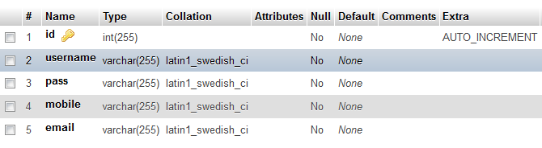

bookEntry

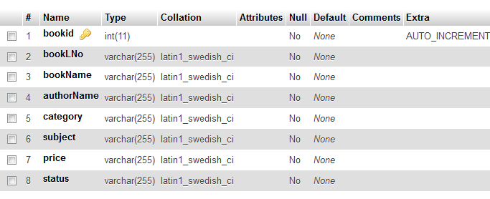

32

bookIssue
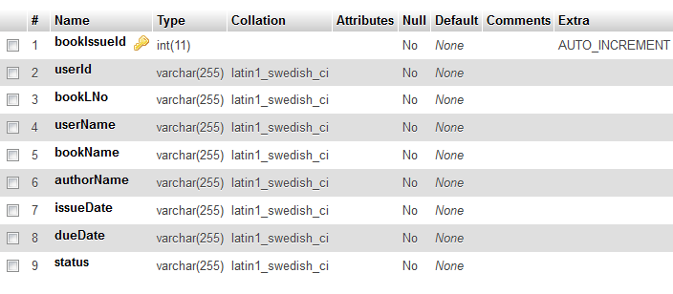
bookReturn
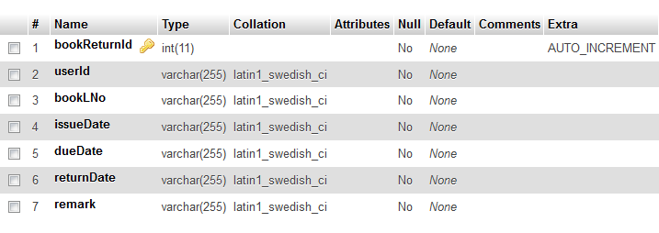

33
OUTPUT

login.aspx

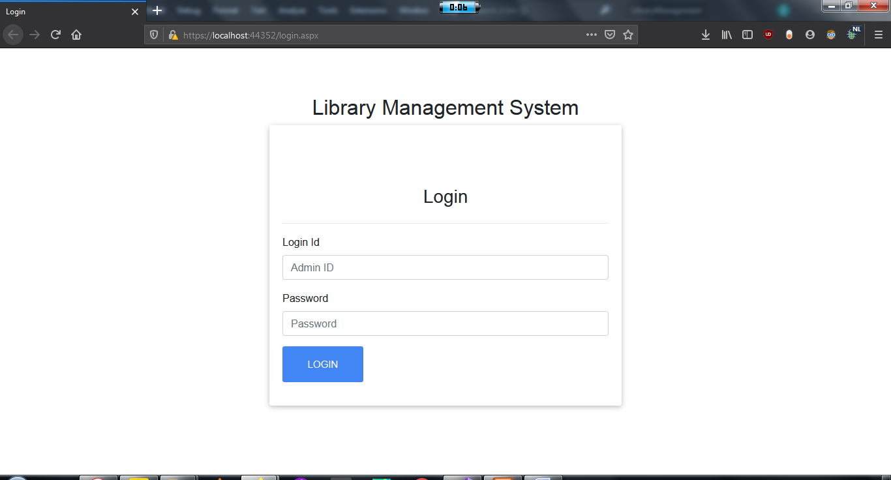

home.aspx


34

bookEntry.aspx

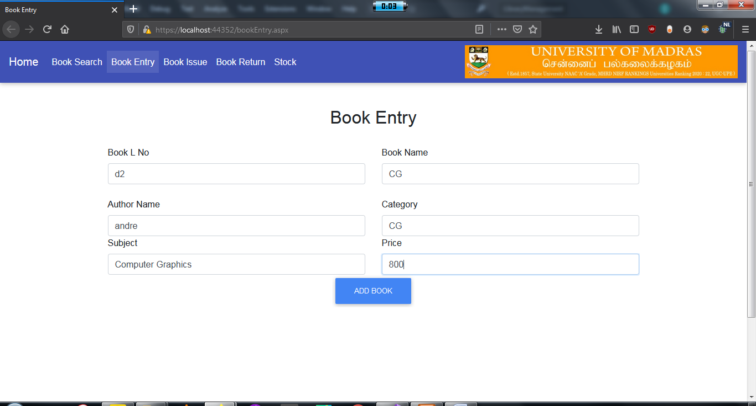

bookSearch.aspx

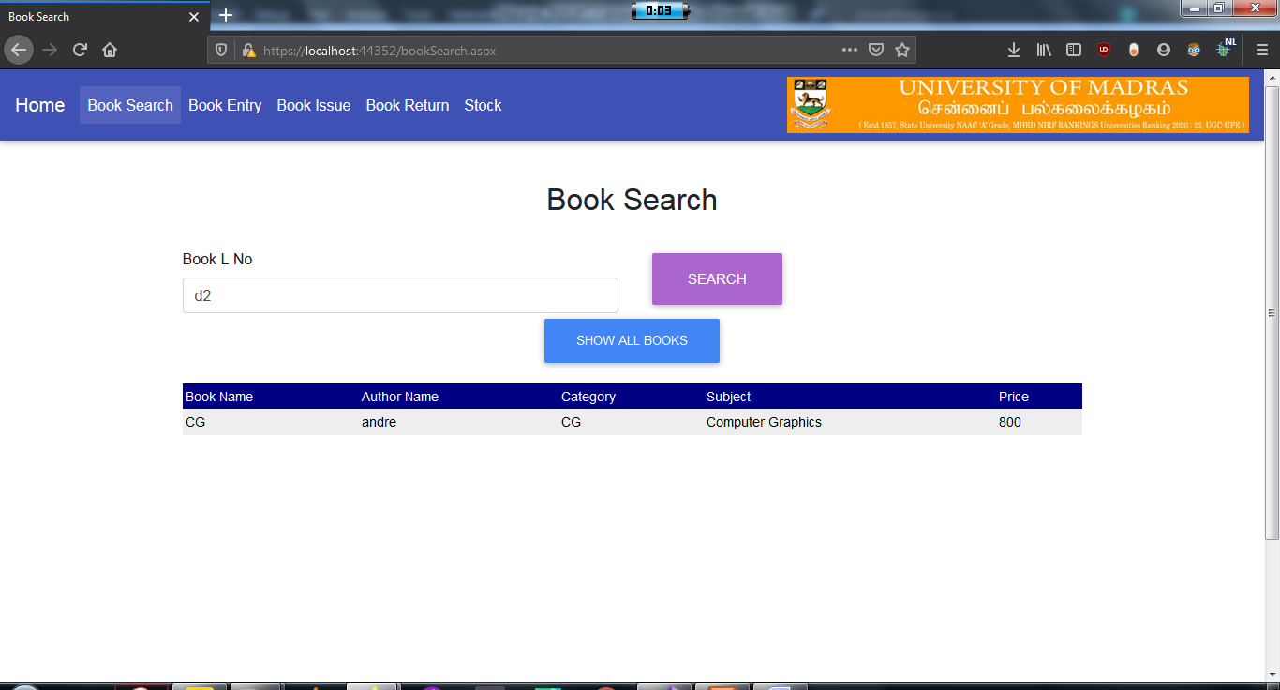

35

bookIssue.aspx
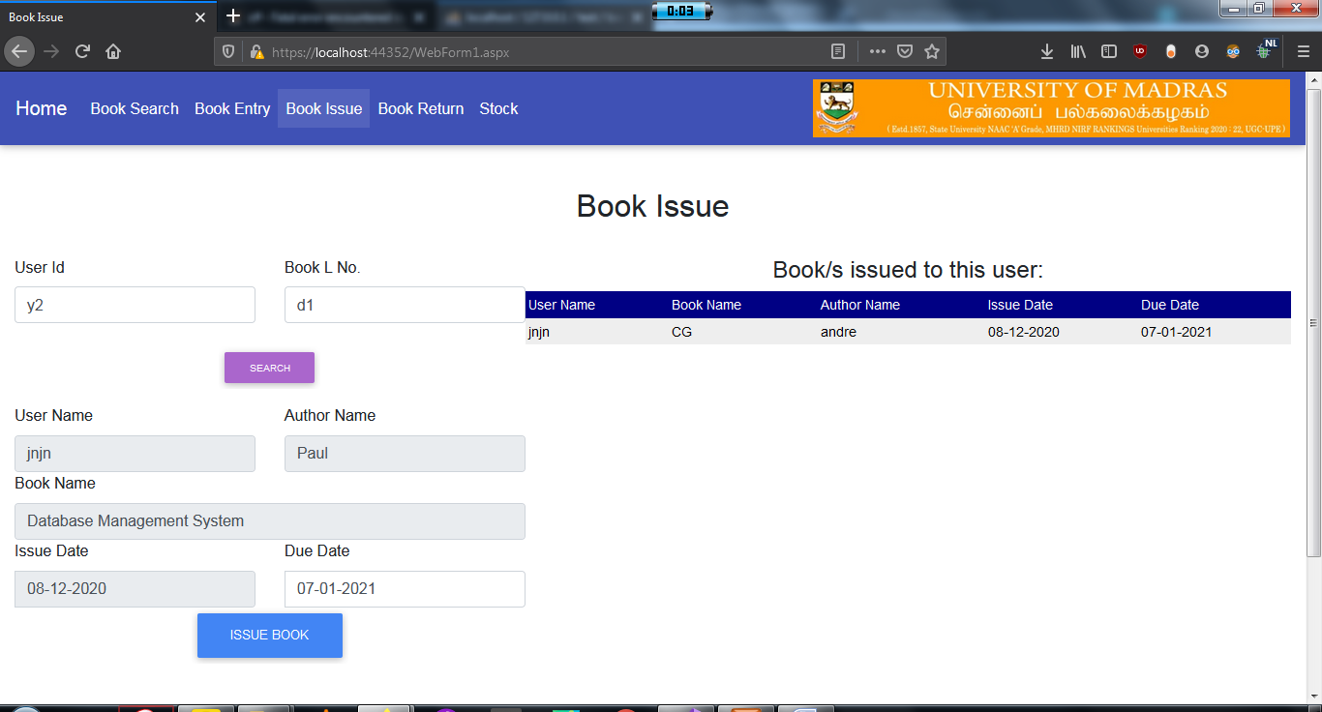

bookReturn.aspx

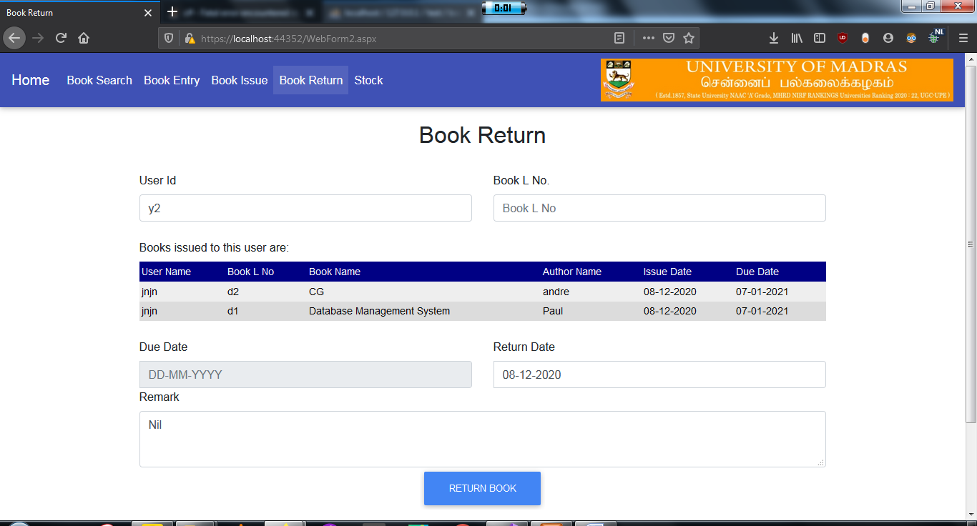

36

Stock.aspx
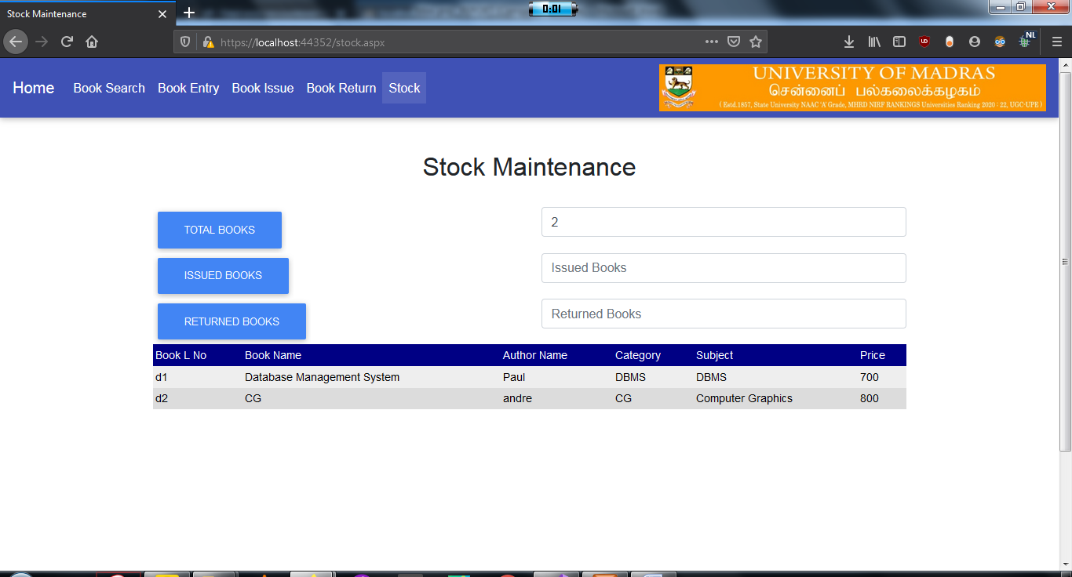

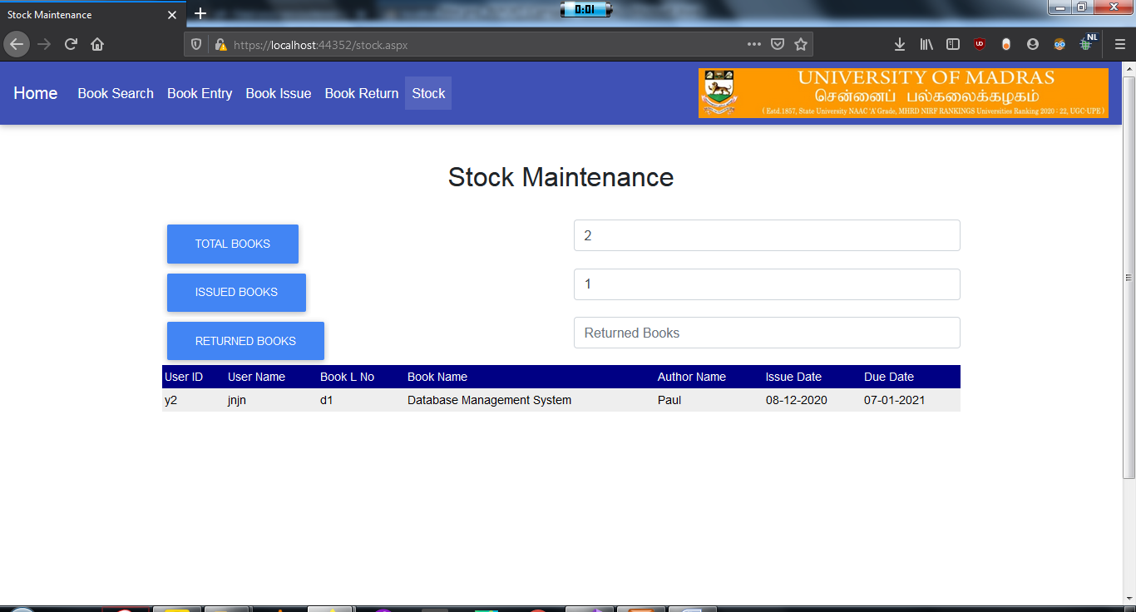

37

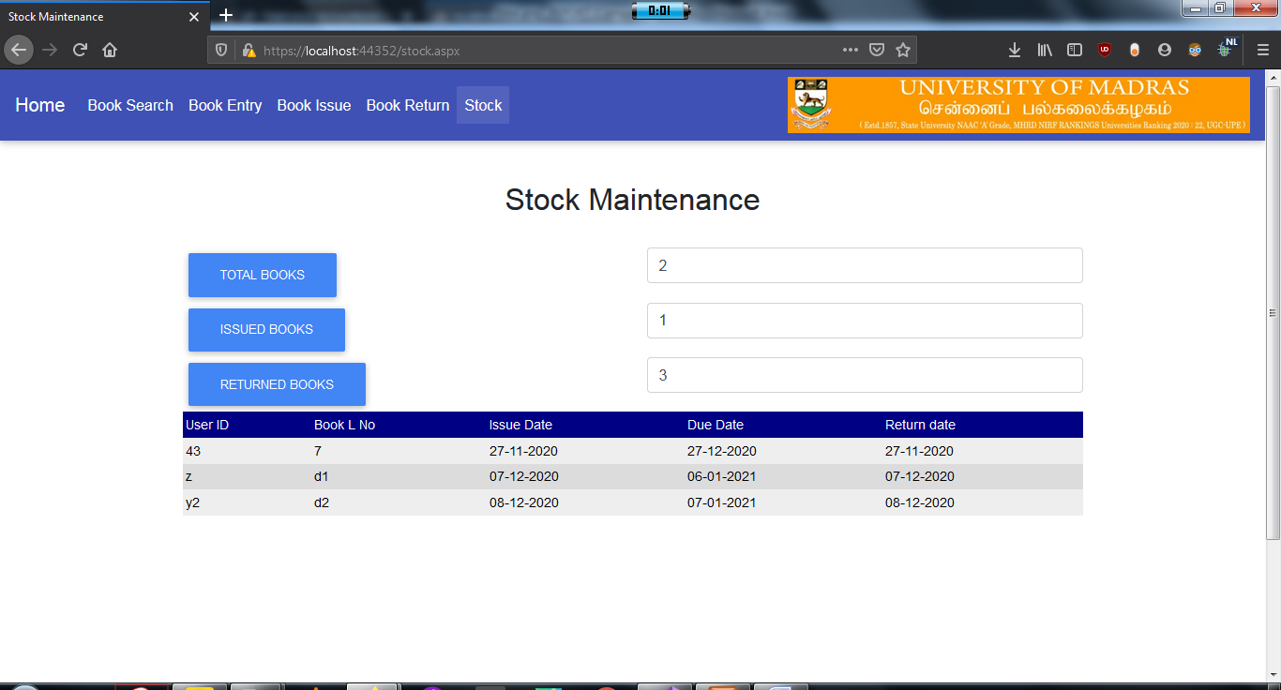

38
CONCLUSION

The project is a web based application has been analyzed, designed and developed in a successful manner with the design considerations for a website. This is a web-based application that will perform in online mode which has been done with the help of MySQL, ASP.NET and C#. This software allows storing the details of all the data related to library. The implementation of the system will reduce data entry time and provide readily calculated reports.

39
REFERENCES

- https://www.researchgate.net/publication/320119228_ Design_and_Implementation_of_Library Management System

- https://www.tutorialspoint.com/asp.net/asp.net_intro duction.htm

- https://www.guru99.com/what-is-asp-dot-net.html

- https://www.javatpoint.com/asp-net-web-form-introduction

- https://stackoverflow.com/

- youtube.com/results?search_query=library+management+system

40

